

Department of Electrical and Electronic Engineering

CPT109 C Programming and Software Engineering 1

CPT109 C Programming Report

Name : Tiankuo.Jiao Student ID : 1929098
Catalogue

1.Specification（Problem statement） 3
1.1 Description of tasks and function 3
1.2 Error analysis and solutions 3
1.2.1 Error 3
1.2.2 Solutions 4
2.Analysis 4
2.1 Main menu flow chart 5
2.2 The flow chart of drawing the game: 6
2.3 The flow chart of the game 7
2.4 On an input 8
2.5 On Outputs 8
2.6 Data structure 8
2.6.1When I want to draw random groups of numbers 9
2.6.2 Draw a matrix 9
2.6.3 When comparing two characters for equality 9
2.7 Algorithm 10
3.Design 10
4.Testing 11
4.1 Account creation and login section 11
4.2 The part of main menu 13
4.3 Game section: 15
5.Existing limitations 17

Implementation 17

Specification（Problem statement）:

1.1 Description of tasks and functions

The task here is to make a simple game called“Find the Pairs”. In this game, a player is shown a grid of randomised pairs of symbols to memorise in a short time. The player then selects pairs of objects to uncover, which remain uncovered if they match. The aim is to turn over all pairs in the smallest number of attempts possible.

Therefore, this program provides the following functions:

1.Account registration: When a player plays the game in the first time, he/she needed to register an account. After that, he/she can play the game normally.And the program will prompt you to register again if the newly registered account and the previous account have same name and password.
2.Login account: The program will remember each account. If the account and password do not match, the program will prompts you to input them again.

3. Check the records. Players can check the records of previous games after playing the game according to the difficulty selected by the player.

4.Recording information: Each time the user plays will be recorded and can be viewed in the historical record. The recorded information includes:

(1)Time: The amount of Time a player plays a game

(2) Number of attempts: The total number of attempts by the player

(3) Difficulty: The difficulty chosen by the player

- Clear game History: If the player chooses to erase game history, the history will be erased including time、attempts、difficulty.

- Users can choose four different difficulties, including:
1 Beginner(4*4)
2 Intermediate(6*6)
3 Expert(8*8)
4 Hell (10*10)

Each difficulty will be recorded separately for the player to view.In addition, players can choose to go back to the main menu at any time in the game.

7. Players can jump to the main interface in the game

8. Save records: Players can save their history when they exit

- Logout without saving: Players can choose to logout their accounts

1.2 Error analysis and solutions

1.2.1 Error

Considering that the player may have typed incorrectly, we have also taken into account the problem of errors. Possible errors include:

1. The player may not remember his/her previous account, and may enter the account that has been registered

2. Account password is forgotten and cannot be matched

3. Enter non-numbers during the game

- The number entered during the game is greater than the maximum value contained in the game (4*4 is 16, 6* 6 is 36, 8* 8 is 64, 10* 10 is 100).

5. The user may enter more than 1-5 numbers and special characters in the main menu.
1.2.2 Solutions

1. When the player enters the same account, the same account will be identified through the program , and the user will be prompted to re-enter.

2. When the user forgets the password, the user should be prompted to register again.

- Error should be prompted when the game enters non-number, prompting the user to re-enter.

2.Analysis：
The task asks the user to play a game called “Find the pairs”, but the user may enter the digits incorrectly,and the user may enter the wrong account information causing the program to fail. Therefore, it is necessary to consider how to solve this problem. The error cases mainly include the above points. It is necessary to judge whether the user has entered the correct number and account.The output result contains the number of user attempts and The time spent by The user.

2.1 Main menu flow chart:
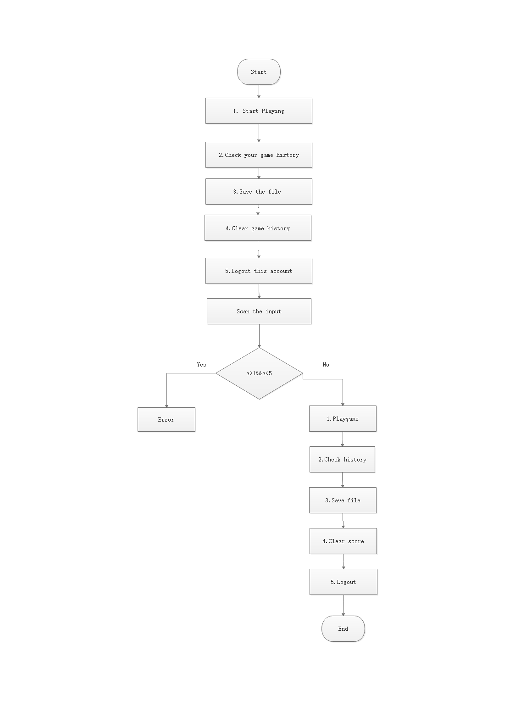
2.2 The flow chart of drawing the game:
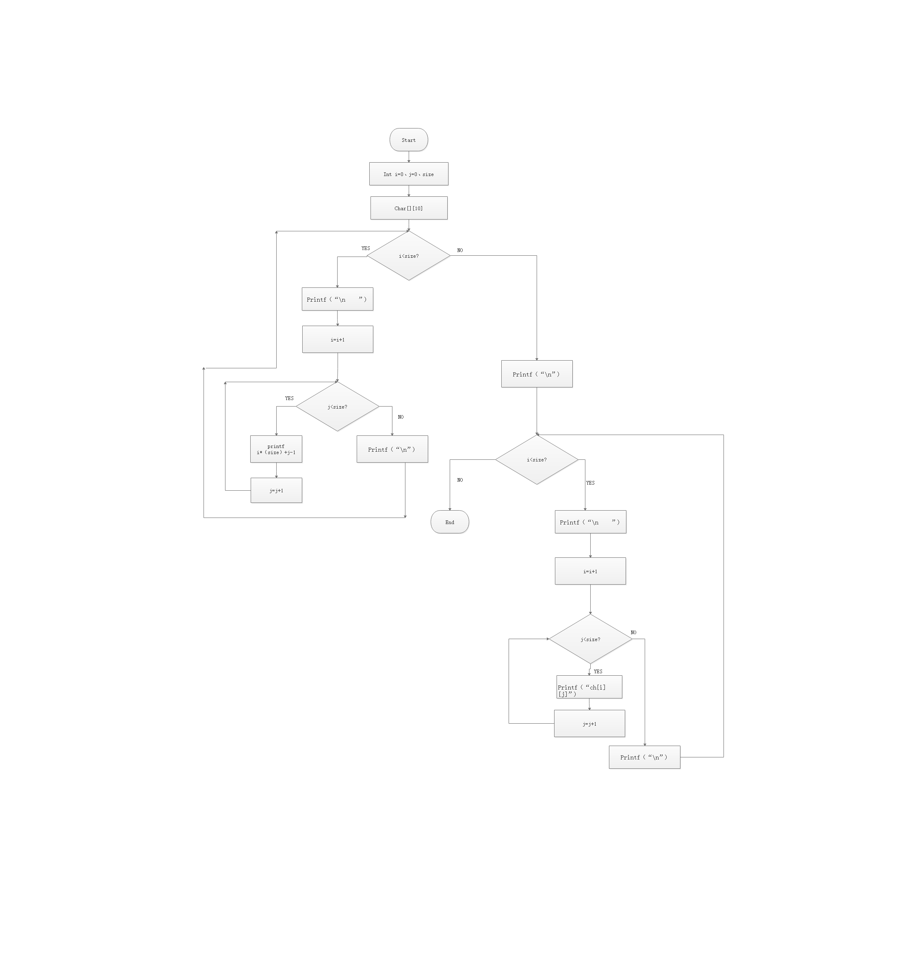

2.3 The flow chart of the game:

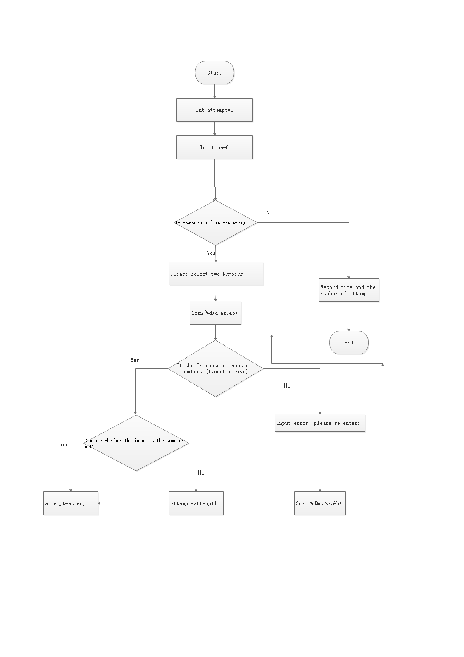

2.4 On an input：
Login interface: Players need to enter their account password in the initial interface. If there is no account, players need to create it in advance. In addition, players need to remember their passwords.
Main menu interface: Player selection function, enter the number selection function between 1-5:
1.Start Playing
2. Check your game history
3. Save the file
4. Clear game history
5. Logout this account
When the player selects input to start the game, the player can choose the difficulty. When a player chooses to view history, clear history, and so on, the program performs these actions.
Game interface: the player needs to remember the position of the same character, and input the position serial number.

2.5 On Outputs:
In the login game and main menu interface, the game will recognize the number entered by the player, if the input character does not meet the requirements，then the program will prompt an error.
The game will identify the number entered by the player. If the match is successful, the characters will be displayed until the player matches all the characters successfully, and then the game is over. At the same time, the game will also record the player's time and the number of attempts.

2.6 Data structure:
I have allocated two arrays, one is a random number group, the other is an "~" array, and the two arrays are:
char ch[][10]
char ch_rand[][10]
Among them, because the game is divided into four difficulties, the array is not fixed, will be generated according to the user's choice. If the user selects 4 by 4 difficulty, both arrays will also be 4 *4.
2.6.1When I want to draw random groups of numbers:

I selected the rand（）function, and the columns and columns randomly generated have the following subscripts:
tx1 = rand() % size
ty1 = rand() % size
tx2 = rand() % size
ty2 = rand() % size
First we define the value of the card char card = '! ', and then we loop through the characters to the matrix,
Then the case of tx1 = tx2 and ty1= ty2 is excluded:
if (ch_rand[tx1][ty1] == '~' && ch_rand[tx2][ty2] == '~')
ch_rand[tx1][ty1] = card + rand_count
ch_rand[tx2][ty2] = card + rand_count
rand_count++
这样就可以保证只有两个字符，且每一次游戏时字符的随机。

2.6.2 Draw a matrix：
I need to list 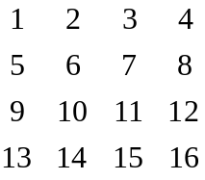
Therefore, we can choose to use two loops to complete:
int i, j;
system("cls");
for (i = 0; i < size; i++) {
printf("\n ");
for (j = 0; j < size; j++) {
printf("%-5d", i * size + j + 1);
}
}
2.6.3 When comparing two characters for equality:
tx1 = (a - 1) / size;
ty1 = a % size - 1;
if (a % size == 0) {
ty1 = size - 1; }
tx2 = (b - 1) / size;
ty2 = b % size - 1;
if (b % size == 0) {
ty2 = size - 1; }
The following sections determine if the selected characters are equal：
if (ch_rand[tx1][ty1] == ch_rand[tx2][ty2]) {
ch[tx1][ty1] = ch_rand[tx1][ty1];
ch[tx2][ty2] = ch_rand[tx2][ty2];
And then，turn over the card.
2.7 Algorithm:
In the part of algorithm, I mainly use algorithm in game design.In game programming, we first declare two arrays, one of them is randomly generated array, and the other is an array of all consists of "~", when the players choose the same character, the two parts of the "~" will change into the same characters. ( for example 4 * 4 matrix) for each of successful match, the variables increase 1.when the variable is equal to 8, the game succeed. And the player can exit or to play a game again.
3.Design
1. Design a structure, including: num[40]; code[30];score44[100]; time44[100];index44;
2.Add functions
3.Clear game history：Reset the number of attempt and time
4. Function design:
4.1 createUser(struct user users[])
When the user enters the same account and password, the program should be able to tell the user that the account password has been created.

4.2 readFile(struct user users[])
Determine whether the account password file exists. If it exists, open the file. Otherwise, create a file. Reads the file contents into the user structure array and closes the file.

4.3 void saveFile(struct user users[])
Writes the entire contents of the structure array to the file.

4.4 loginUser(struct user users[])
When the user enters the account and password do not match, the user should be told to re-enter the password. If the password is forgotten, the user should re-create the account.

4.5 void mainMenu(struct user users[])
1.Start Playing
2. Check your game history
3. Save the file
4. Clear game history
5. Logout this account
After the user has selected the function, it will jump to the function interface selected by the user. If the user enters a number not in the range of 1-5, the system will prompt an error.When the user selects 1, the user selects the difficulty. The game has four difficulties (4*4, 6*6, 8*8, 10*10).

4.6 void printGame(char ch[][10])
Draw the matrix selected by the user

4.7 void gamePlay(struct user users[])
At the beginning of the game, the player has a time memory of 5 seconds. The player enters any two numbers and displays them if the numbers correspond to the same characters until all the characters are matched. When a player has successfully played the game, the system will record the player' time and the number of attempt.
If the player enters a non-number character, the system will prompt him to input again.
If the player inputs more than the maximum value of the matrix, the system will prompt for re-input.

4.8 void checkGame(struct user users[])
At the end of the game, players can view their own game history. Game records will be marked with different difficulty levels. Players can check the number of each attempt and playing time.

4.9 void logoutUser(struct user users[])
Players can choose to logout their account.
5.When the user selects the corresponding function, the program will execute the program according to the user's choice. To prevent user input errors, the program will alert the player and report the error when the user enters an error character. (For example, the player may enter the wrong character in the game, and the program will tell the user to enter the wrong character and remind the user to re-enter)
4.Testing

4.1 Account creation and login section

Test 1

Create a new account and password：For example:Account:Mark;Password:Mark

Test result:

Please enter the account name you would like to use:Mark
Searching database this may take a moment, please wait...
Please enter the password you would like to use:Mark
Please enter your password again:Mark
You have successfully created and credited your account, you are now logged in...
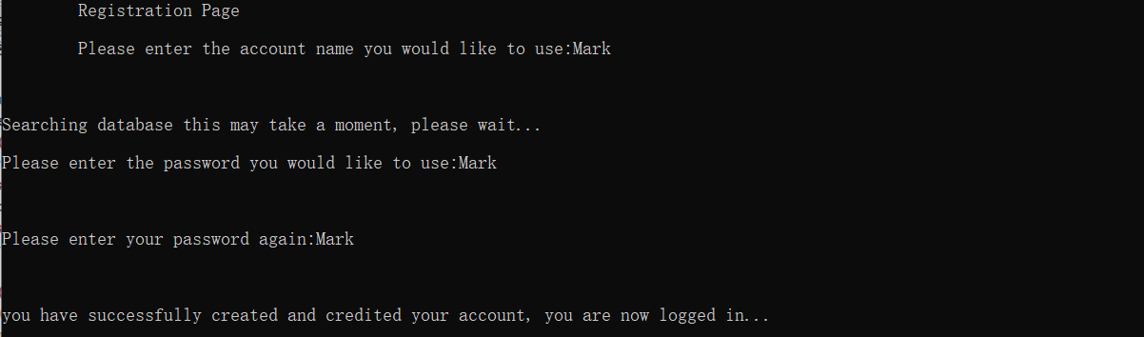

Test 2

Login to the account you just created:For example:Account:Mark;Password:Mark

Test result:

Players can login to the game normally.

Test 3

The account entered was not created：For example:Account:Mark; Password: Mark

Test result:

Incorrect account or password.
Please enter your account number: 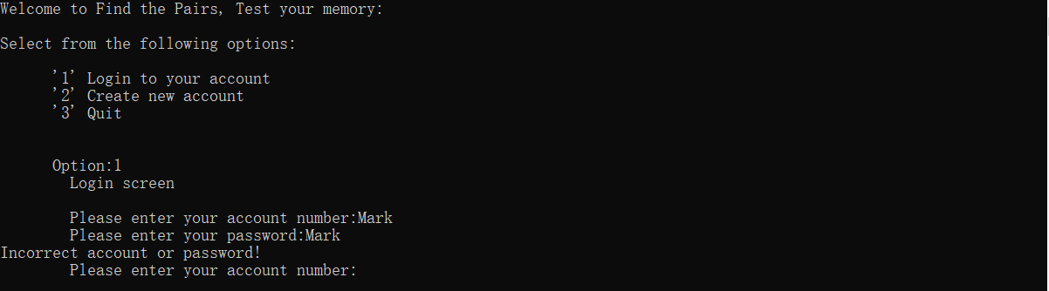

Test 4

The account passwords you entered do not match：For example: Account:Mark; Password: Mark%

Test result:

Incorrect account or password.
Please enter your account number:

Test 6

Create a newly created account

Test result:

The system will tell you that the account has been created and prompt you to create another account.

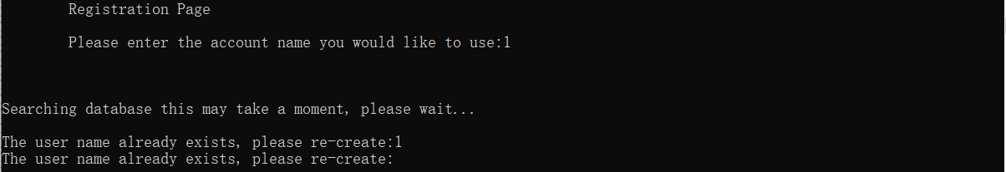

Test 7

The user chooses "Quit" to exit the program

Test result:

Program exits

2.The part of main menu

Test 1

View history: The history will be recorded and saved separately.

Test result:

The history will be saved in four parts, including the time and the number of attempts
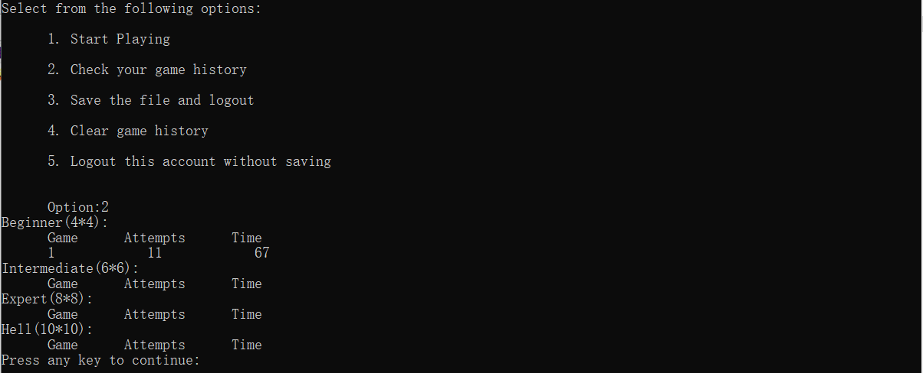

Test 2

Clear history section: All history will be cleared.

Test result:

The time and number of player attempts reset to clear 0

Test 3

Account cancellation: All accounts and passwords of players will be canceled.

Test result:

Saved account information will be erased.

Test 4

Save the File and logout: All player information will be saved.

Test result:

New information created by the player in the game will be saved.

Test 5

Save when there is no information

Test result:

The system will prompt you for a save error

Test 6

When more than 1-5 numbers are entered

Test result:

The system will prompt an error

Test 7

When special characters are entered

Test result:

The system will prompt you for a save error

4.3 Game section:

Test 1

Play the game(4*4)，input 1 2 and 2 3.

Test result:

First show the game interface, including: prompt matrix, "~" matrix, and prompt for two numbers.

Enter 1, 2, and the card will be shown to the user but flipped back.

Enter 2, 3, and the card will always be shown to the user.

Test 2

Input the wrong characters: 1 p

Test result:

After being prompted for a number, for example: enter two characters of 1 p (incorrect number), the system will prompt an error and re-enter.

Test 3

Input the wrong characters: 1 %

Test result:

After being prompted for a number, for example: enter two characters of 1 % (incorrect number), the system will prompt an error and re-enter. Here is screenshot of the wrong tests.
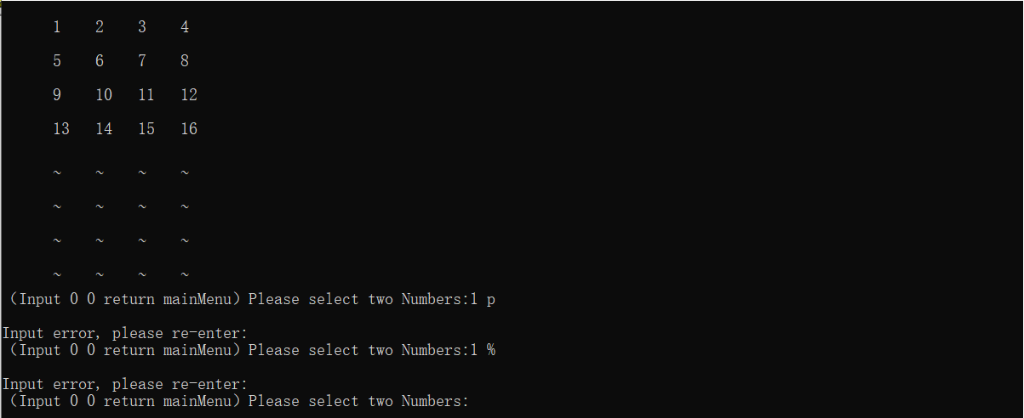

Test 4

Try the games on different difficulty levels (6*6,8*8,10*10) and check the history.

Test result:

The game will run correctly and records will be kept separately.

Test 5

In the game test，i entered 0 0 to return to the main menu.

Test result:

In the game after entering 0 0 ,the program jumps to the main menu.

Test 6

Test whether the game time and the number of attempts are accurate.

Test result:

There may be a slight error in the time, but it can be ignored. I found no problem in the number of attempts section.

Test 7

Test if the data still exists after “Logout without saving.”

Test result:

After testing, the data is erased after the user selects “Logout without Saving”.

Existing limitations:

1. If the user forgets the account or password, the user cannot retrieve it through the system prompt, and the user needs to create the account again.

- The game provides four kinds of difficulty, but some players may prefer to set the game by themselves, and players may prefer to play customized games, including setting the number of cards.

3.When drawing a random matrix, it is possible to generate the same characters all the time, causing the game to not play properly，but the odd of that happening are extremely low(far less than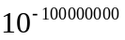).
Implementation
1929098_2.c

